**Phase-4 Practice Project: Assisted Practice -**

**1.Create a angular project:**

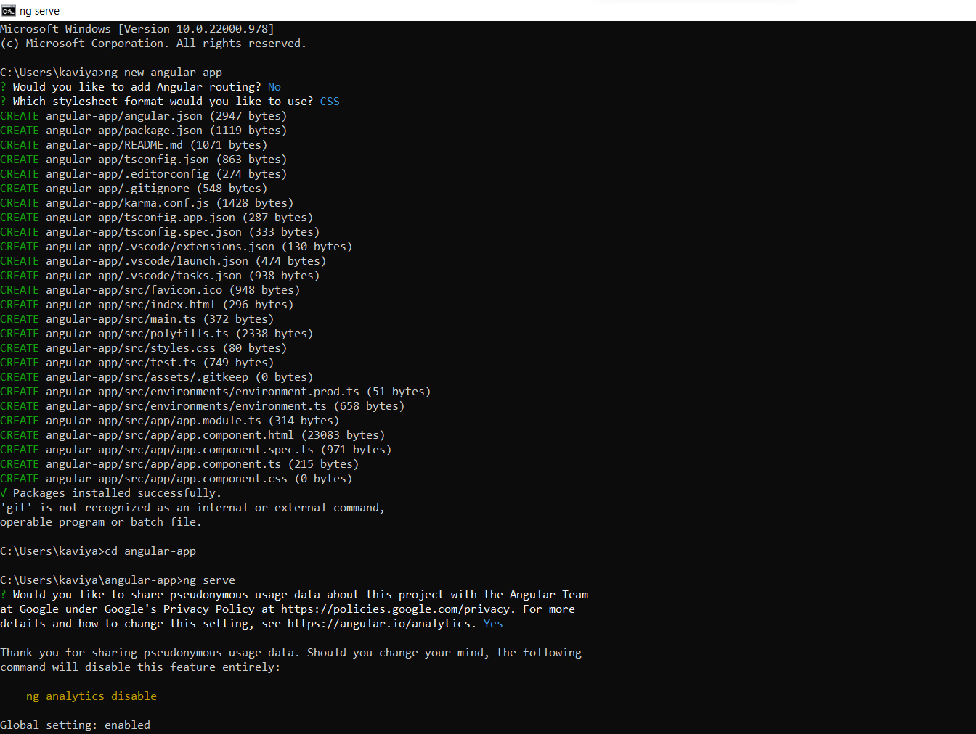

**Open Visual studio code:**

**Source Code:**

**App.module.ts:**

import { NgModule } from '@angular/core';

import { BrowserModule } from '@angular/platform-browser';

import { AppComponent } from './app.component';

import { ProductListComponent } from './Products/product-list.component';

@NgModule({

  declarations: [

    AppComponent,

    ProductListComponent

  ],

  imports: [

    BrowserModule

  ],

  providers: [],

  bootstrap: [AppComponent]

})

export class AppModule { }

app.components.ts:

import { Component } from '@angular/core';

@Component({

  selector: 'app-root',

  template:'<product-list></product-list>',

  styleUrls: ['./app.component.css']

})

export class AppComponent {

  title = 'angular-app';

}

Product-list.component.html:

<h1> Product List Page </h1>

Product-list.components.ts:

import { Component } from "@angular/core";

@Component({

    selector:'product-list',

    templateUrl:'./product-list.component.html'

})

export class ProductListComponent{

    pageTitle: string="Product List Page"

}

**Output:**

